**Guided Tour for Case Study and Report**

**Diagnostic Analysis Project**

**Call Centre Data Analysis for Sales Manager**

**Created by:** Rekha Devendra

**Created date:** 22nd Feb 2024

**Project Title: Call Centre Data Analysis for Sales Manager**

**Project Summary:** This project focused on analyzing and interpreting sales data from a call center to uncover patterns and trends in agent performance, busyness across various days of the week, and differences between shifts. The analysis was conducted using Excel, with tools such as pivot tables, statistical analysis, and data visualizations to support data-driven decision-making.

**Key Responsibilities:**

* Analyzed call center sales data to address multiple key issues, including:
  + Examining how busyness varies across different days of the week and shifts.
  + Performing statistical tests to determine whether Shift 1 is busier than Shift 2.
  + Creating pivot tables to compare agent types, shifts, days of the week, and trends monthly.
* Developed detailed analysis reports that included visualizations of trends, helping the Sales Manager to make informed staffing decisions.
* Designed and delivered a comprehensive "Guided Tour" in the form of a written report, including screen captures and explanations of analytical findings.
* Packaged the results into a professional case study report, including a cover letter and a Statement of Academic Integrity.

**Skills & Tools:**

* **Data Analysis:** Data cleaning, statistical analysis, and trend identification.
* **Excel:** Pivot tables, data modeling, charting, advanced formulas.
* **Reporting & Documentation:** Writing detailed reports and creating a guided tour of the analysis process.
* **Communication:** Presenting insights and recommendations to senior stakeholders.

**Outcome:**

* Delivered actionable insights on call center agent busyness and shift comparisons, providing the Sales Manager with the data needed to optimize staffing decisions.
* Successfully packaged and delivered a comprehensive case study for review by senior management, showcasing thorough analysis and professional reporting skills.

**Guided Tour: Data Analytics Product for Busy-ness**

This report presents an overview of the Data Analytics product developed for a Call Centre Outsourcing firm. The product is designed to analyze two similar call center datasets provided by a potential client, each representing two distinct business divisions. The analysis aims to support decision-making regarding a potential contract for call center services.

The Excel workbook used for this analysis is titled **"Case_Study_1_Call_Center_Analysis.xlsx"**. The focus of the analysis is on the **"Expert DM"** worksheet, which contains key data models and insights related to agent performance, busyness trends, and shift comparisons. The findings from this analysis will help the firm assess the potential client’s needs and determine staffing requirements, thereby optimizing the decision-making process for contracting call center services.

#### Uncovering the Discoveries: A Detailed Inspection of the Supplied Call Analysis Data Files.

* **Guided Tour of Data Inspection Results:**

In this section, I have carefully examined the provided data to identify any issues that might affect its integrity and overall quality. Below is a summary of the key findings and areas that may require further attention:

1. **No Missing Records in Key Tables:** Both the **TO-Calls-Sprts** and **ProvStates** tables contain records, which addresses initial concerns regarding missing data. This suggests that the datasets are largely intact, but a more thorough review may be necessary to confirm the relevance and accuracy of the records.
2. **Empty Columns in the TO-Calls-Sprts Table:** Upon inspection, I found that two columns—**Quantity** and **Inactive**—are entirely blank in the **TO-Calls-Sprts** table. This raises questions about whether these columns should contain data, whether they were inadvertently left empty, or if they have been intentionally excluded. Further investigation into the purpose of these columns is recommended.
3. **Blank Cells in Critical Columns:** I identified **509 blank cells** in the **CallStartTime** and **CallTimeSecs** columns of the **TO-Calls-Sprts** table, out of a total of **13,572 records**. These missing values could potentially affect any time-based analysis or insights drawn from these fields. It would be prudent to address the missing data by either filling in the blanks, investigating the cause of the missing information, or excluding these records from certain analyses if they cannot be corrected.
4. **No Mixed Numeric Values Found:** I did not find any columns in the **TO-Calls-Sprts** table containing a mix of positive and negative numeric values. This suggests consistency in the data, which is an encouraging sign for further analysis, as it reduces the likelihood of errors or inconsistencies in numeric fields.
5. **Empty Columns in the ProvStates Table:** Similar to the **TO-Calls-Sprts** table, the **ProvStates** table also contains empty columns, specifically **CountryID** and **Inactive**. It is important to clarify whether these columns were meant to contain values, if they are necessary for analysis, or if they are irrelevant. Further clarification on their intended use will help ensure the completeness and accuracy of the dataset.
6. **Blank Cells with Mixed Data in the ProvStates Table:** In the **ProvStates** table, I observed **65 blank cells** in the **Timestamp** and **zLnk** columns, out of **88 records**. The presence of these blank cells could hinder the ability to perform time-based or linked data analyses. It is recommended to investigate the cause of these blanks and determine if they can be filled or if adjustments to the dataset are necessary.

#### Unlocking Insights: Data Discovery through Cluster Analysis for Agent type Expert DM

* **Expert DM Modes Screenshot.**

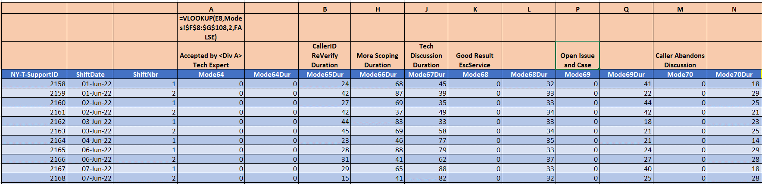

#### Expert DM Calculation Screenshot.

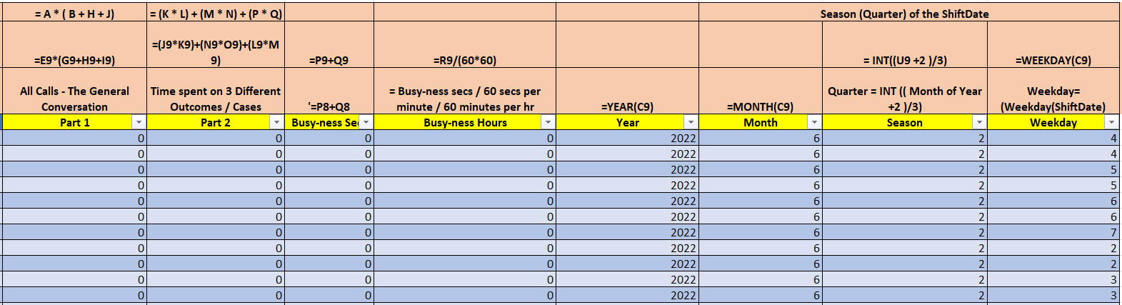

* **Guided Tour of Expert DM: Busy-ness Calculations and Temporal Analysis**

This section provides a detailed look into the **Expert DM** dataset, focusing on the busy-ness calculations and how various temporal attributes are used to gain insights into call support operations. Below is an overview of the key components involved in the analysis:

1. **Data Columns:** The **Expert DM** dataset contains multiple columns, each representing different aspects of call support. Key columns include:
   * **NY-T-SupportID**: Unique identifiers for support calls.
   * **ShiftDate**: The date of the shift during which the call took place.
   * **Mode64 to Mode70**: Call modes, which categorize the types of calls.
   * Temporal attributes like **Year**, **Month**, **Season (Quarter)**, and **Weekday** are also incorporated, providing additional layers for analysis and helping to identify patterns over time.
2. **VLOOKUP Function:** The **VLOOKUP** function, such as =VLOOKUP(E8, Modes!$F$8:$G$108, 2, FALSE), is employed for data retrieval and cross-referencing. In **Expert DM**, this function helps extract the mode descriptions for the respective modes (from Mode64 to Mode70) by referencing the **Modes** tab. This enables the dataset to contain detailed information about the type of calls, making the analysis more comprehensive.
3. **Calculation Operations:** Several formulas are used to compute important metrics, such as:
   * =E9*(G9+H9+I9) and =(J9*K9)+(N9*O9)+(L9*M9) are used to calculate **Part 1: "All Calls - The General Conversation"** and **Part 2: "Time Spent on 3 Different Outcomes / Cases"**, respectively.
   * The formula =P9+Q9 aggregates these two parts, potentially representing the total **Busy-ness Seconds** for the given call.
   * To standardize time and make it more interpretable, the formula =R9/(60*60) converts the **Busy-ness Seconds** into **hours**, which helps in presenting the data in a more digestible format (i.e., hours instead of seconds).
4. **Year, Month, and Weekday Calculation:** Temporal analysis is central to understanding trends in call support. The formulas =Year(C9), =Month(C9), and =Weekday(C9) extract the **Year**, **Month**, and **Weekday** from the **ShiftDate (C9)**. These attributes are essential for grouping and analyzing call patterns across different times of the year, months, and weeks.
5. **Season (Quarter) Calculation:** To segment the data further, the formula =INT((U9 + 2) / 3) is used to determine the **Season (Quarter)** corresponding to each **ShiftDate (C9)**. This allows for the analysis of call patterns and busy-ness trends based on quarterly cycles, providing insights into seasonal effects of on-call support operations.
6. **Temporal Attributes:** The columns for **Year**, **Month**, **Season**, and **Weekday** are key for identifying temporal trends in the data. These attributes allow for more granular analysis of call patterns over time, helping to uncover insights into call volume fluctuations, agent performance, and overall call center efficiency.

#### Analysis of Busy-ness Seconds Across Weekdays and Years (For week 2)

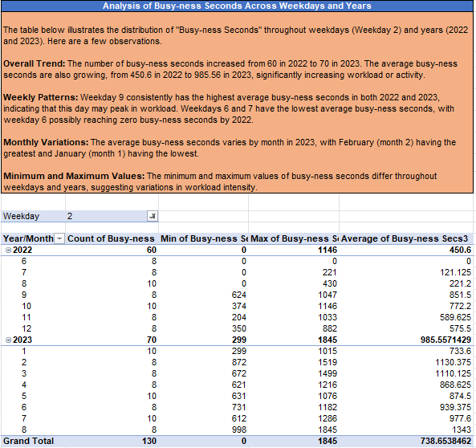

#### Analysis of Busy-ness Seconds Across Weekdays and Years (For multiple weeks 3 and 4)

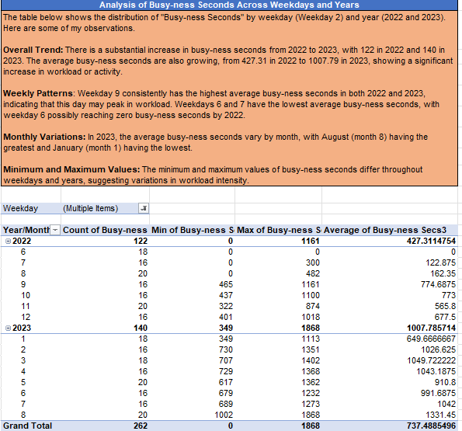

* **Analysis of Busy-ness Seconds Across Weekdays and Years (For Week 5)**

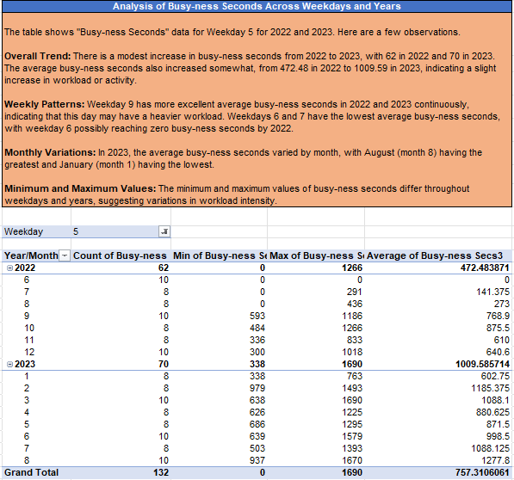

#### Analysis of Busy-ness Seconds Across Weekdays and Years (For week 6)

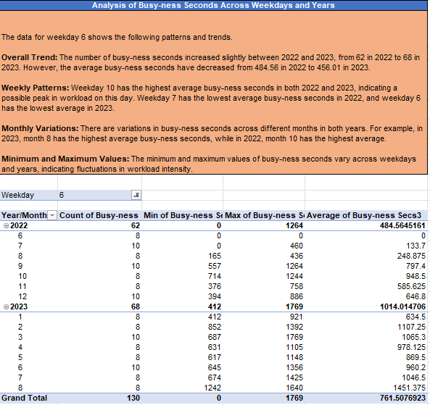

**Conclusion:** This project has provided comprehensive insights into the call support operations over the two years, with a focus on busy-ness seconds as a key performance metric. The analysis of temporal patterns (such as weekdays, months, and years) has uncovered significant trends, including:

* **Increased Workload:** There is a clear upward trend in busy-ness seconds from 2022 to 2023, highlighting the growing demands on call support teams and emphasizing the need for optimized resource management.
* **Peak Days and Off-Peak Periods:** Certain weekdays, such as **Weekday 9**, show a consistently high workload, suggesting potential areas where additional staffing may be needed. Conversely, **Weekday 6** and **Weekday 7** appear to experience lower activity, offering opportunities for operational adjustments or better resource allocation.
* **Monthly Demand Fluctuations:** Monthly variations, with **August** showing the highest demand and **January** the lowest, point to seasonal effects that could inform strategic planning for peak and off-peak periods.
* **Fluctuating Intensity:** Variations in the minimum and maximum busy-ness values further emphasize the fluctuating nature of call center operations, suggesting the need for adaptive staffing models to account for unpredictable spikes or dips in activity.

**Key Recommendations:**

* **Staffing Adjustments:** Consider increasing staffing or introducing flexible work arrangements during peak weekdays and months to maintain optimal service levels.
* **Operational Improvements:** For weekdays with consistently low busy-ness, such as Weekdays 6 and 7, explore ways to optimize shift schedules or redistribute resources more effectively.
* **Strategic Planning:** Use insights into busy-ness trends to inform call center strategy, including potential improvements in workload management, scheduling, and resource allocation to enhance overall efficiency and customer satisfaction.